FET PRACTICAL-3

**Exercise 1:**

**Clara wants to develop a webpage. Where any user login into system there should be a**

**Welcome Message. After that user has to insert his/her name, age and also Confirm that they**

**have entered the age correctly. And on the basis of the age Display if the user is eligible to vote**

**or not. (if age&gt;=18, eligible)**

**with form:-**

<html>

    <head>

        <title>vote eligibility</title>

        <script>

            alert("Welcome! to the webpage.");

            function agev()

            {

                var name = document.getElementById("name").value;

                var age = document.getElementById("age").value;

                var cage = document.getElementById("cage").value;

                if(age==cage)

                {

                    if(age>=18)

                    {

                        alert("Hello!.You are eligible to vote!");

                    }

                    else

                    {

                        alert("Sorry!.You are not eligible to vote!");

                    }

                }

                else

                {

                    alert("You have entered the wrong age , PLease Enter again!!");

                }

            }

        </script>

    </head>

    <body>

        Name : <input type="text" pattern="[a-zA-Z]*" id="name" required autofocus/> <br/><br>

        Age:<input type="text" id="age" required pattern="[0-9]{3}"/> <br/><br>

        Confirm Age:<input type="text" id="cage" required pattern="[0-9]{3}"/> <br/><br>

        <button onclick="agev()">Submit</button>

    </body>

</html>

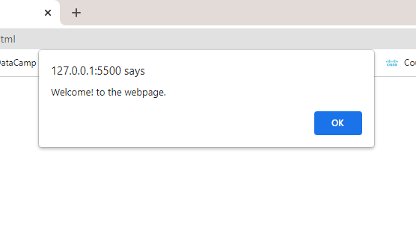

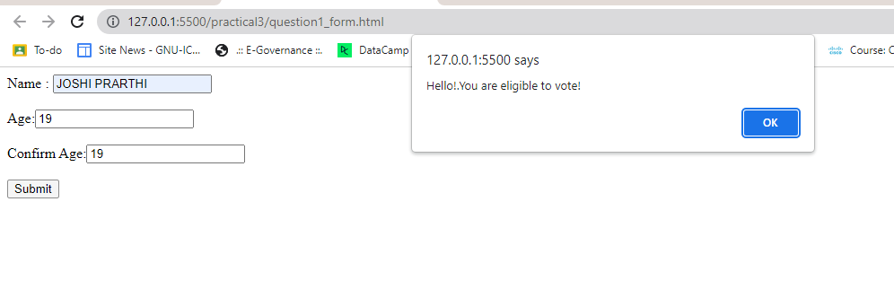

**Without form:-**

<html>

    <head>

        <title>voting</title>

        <script>

                 alert("welcome to voting ");

                 let name = prompt("enter ur name:");

                 let age = prompt("enter ur age:");

                 details = confirm(`Details Entered :\n\tName : ${name}\n\tAge : ${age}\n\nShould we further proceed?`);

                 if (age<18)

                 {

                    alert("sorry!! you are not eligible.");

                 }

                 else

                 {

                    alert("you are eligible.")

                 }

        </script>

    </head>

    <body>

    </body>

</html>

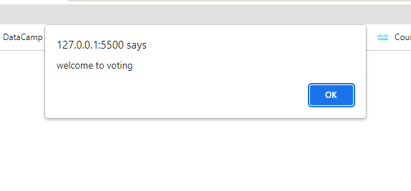

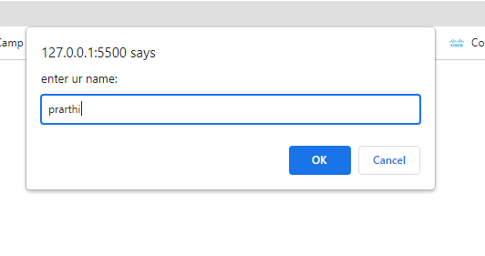

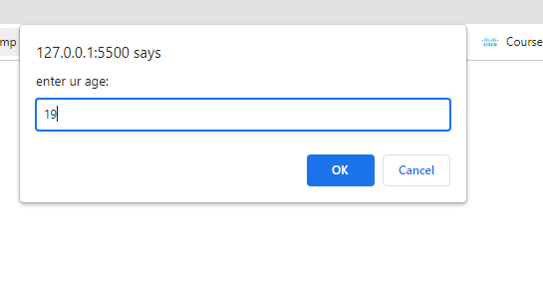

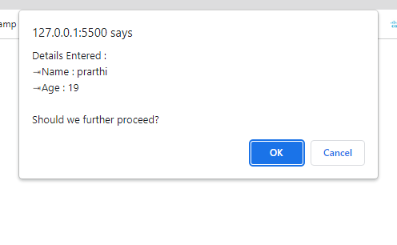

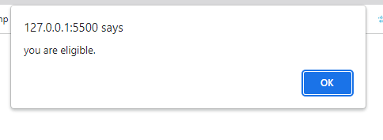

**Exercise 2:**

**Consider CoWin Application where users are supposed to provide their nationality and how**

**many vaccines he/she has got. If user has not been vaccinated for at least 1 dose prompt the**

**Error Message and do not provide further access else give the access into the portal.**

<html>

    <head>

        <title>Cowin Application</title>

        <script>

            let name = prompt("Enter your name:");

            let nat = prompt("Enter your nationality:");

            let vac = prompt("Enter the no. of doses you have taken:");

            txt = confirm(`Name : ${name} \n Nationality : ${nat} \n Doses Taken : ${vac} \n Do you wanna to continue?`);

            if(txt)

            {

                if(vac>=1)

                {

                    alert("You can access the portal!");

                }

                else

                {

                    alert("Sorry! You have to  atleast completed 1 dose, you cannot access the portal!");

                }

            }

            else

            {

                alert("see you next time!!.You pressed CANCEL");

            }

        </script>

    </head>

    <body>

    </body>

</html>

